***C:\Users\Dana\AppData\Local\Microsoft\Windows\Temporary Internet Files\Content.IE5\JOZXMHIC\MCj03984290000[1].wmf***

***Merry Christmas and Happy New Year!***



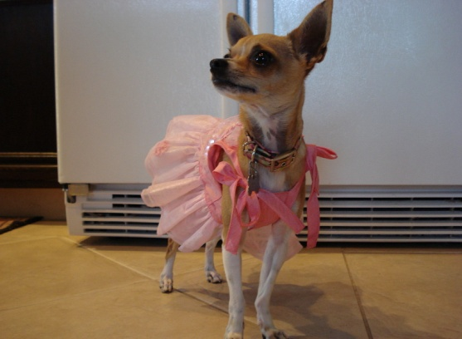

***With Much Love,***

***The Henderson’s,***

***Jeff, Dana, Tanner, Paige and Reeses***

***C:\Users\Dana\AppData\Local\Microsoft\Windows\Temporary Internet Files\Content.IE5\JOZXMHIC\MCj03984290000[1].wmf***