Merry Christmas and Happy New Year!
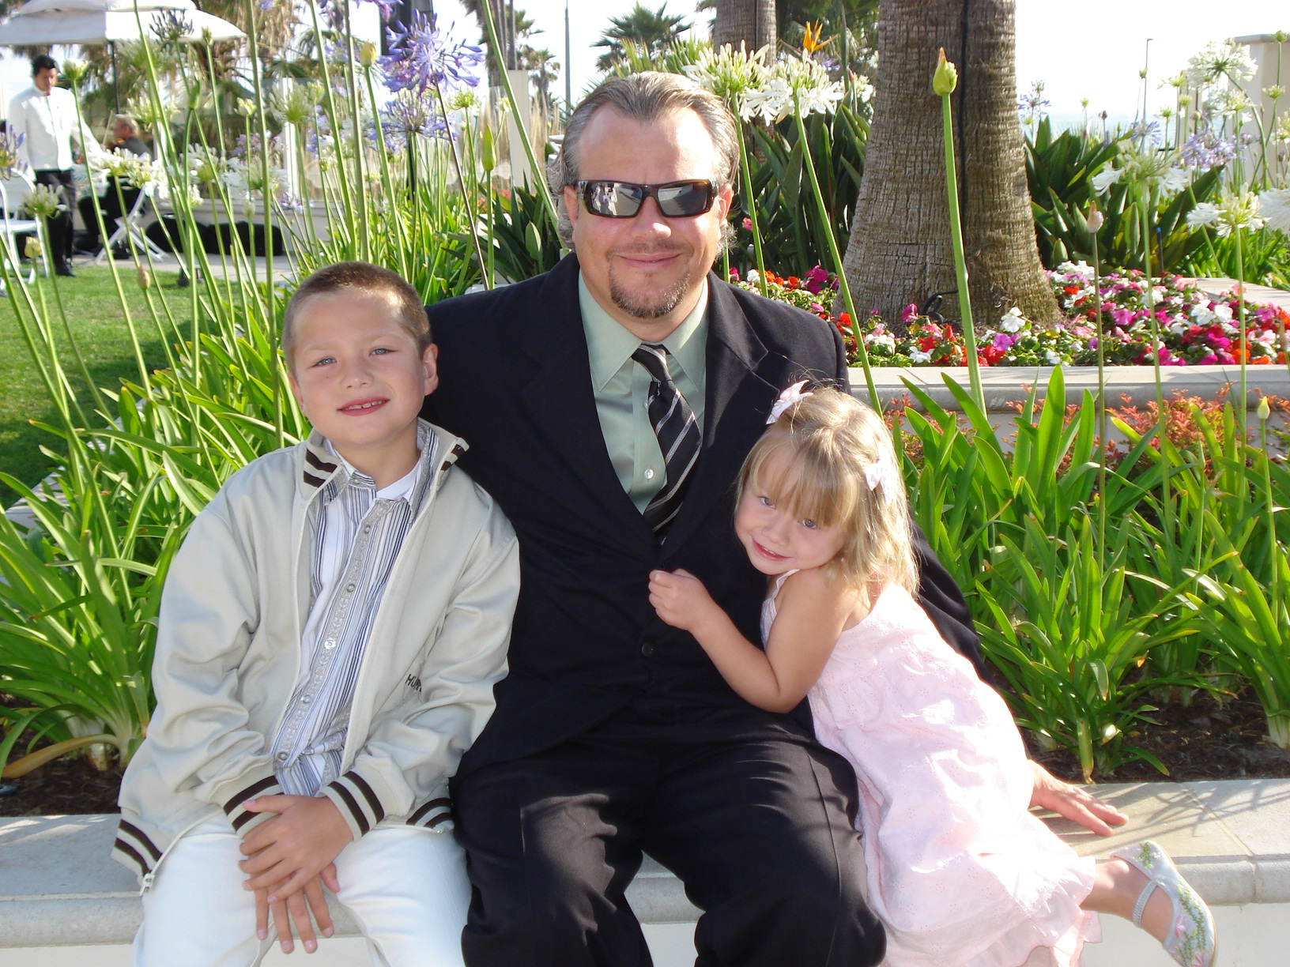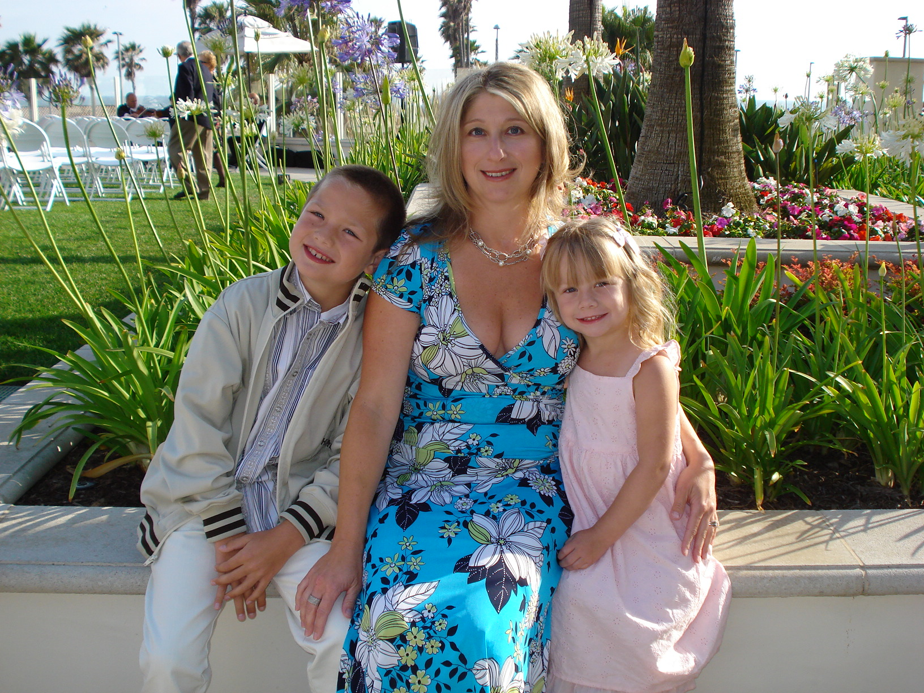
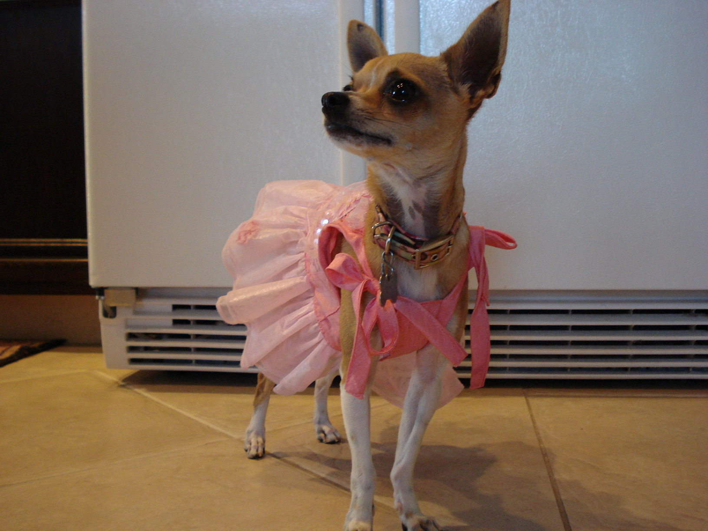
With Much Love,
The Henderson’s,
Jeff, Dana, Tanner, Paige and Reeses

